ADMIN (PHP) GUIDE

1. First, you need to go to the homepage of **Nature’s Fresh Mart** and then you can find LOGIN button at the navigation bar.

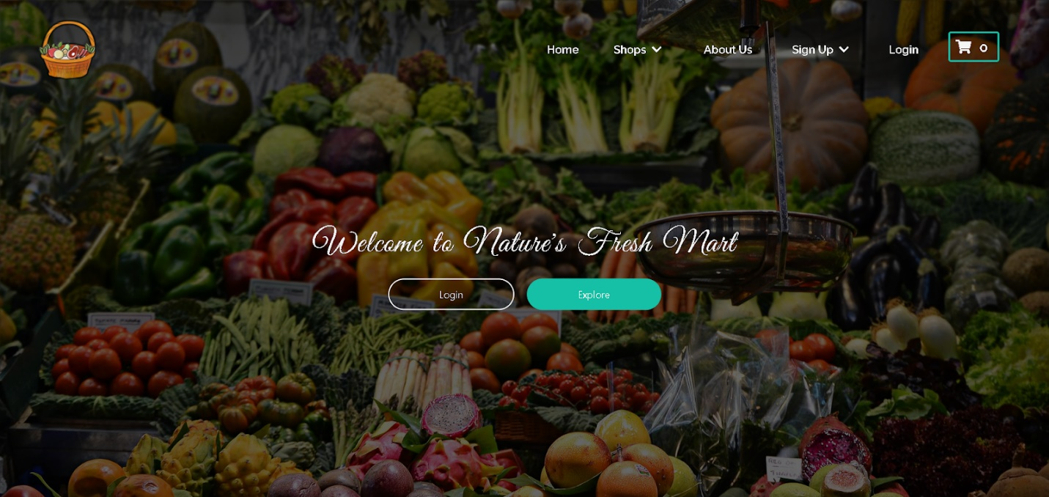

1. Click on the **LOGIN** button and then fill in the form with admin login credentials which can be found in the navigation bar in the **homepage**

Username

**nfmadmin@gmail.com**

Password

Saugat123

(for testing purpose)

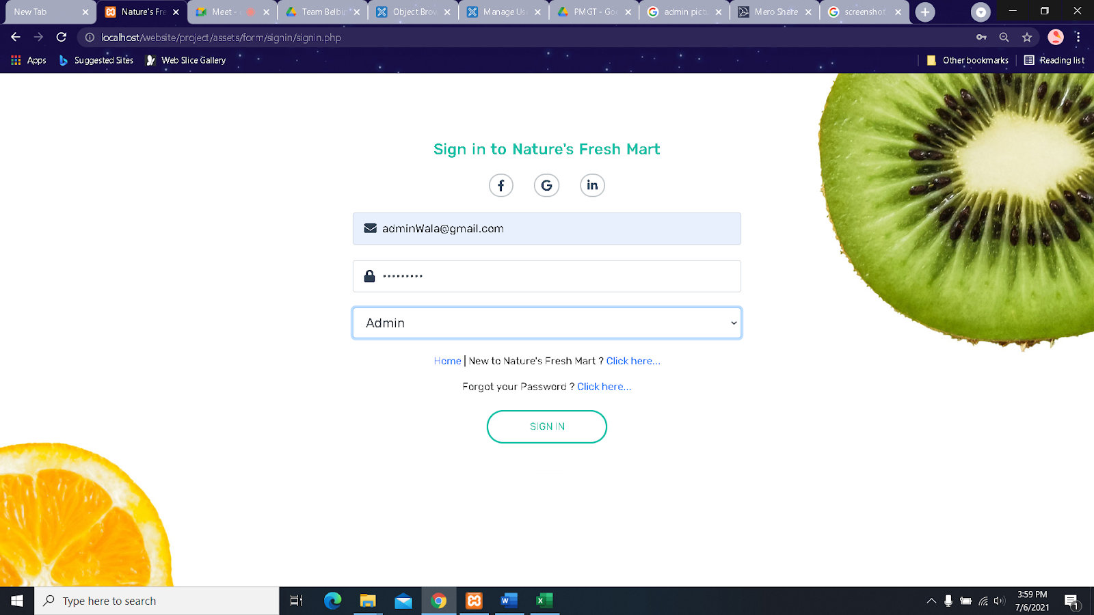

1. Once the correct admin login credentials are filled, you’ll be redirected towards **homepage**, from where you can access the **Admin Panel** by clicking the user icon in the navigation bar

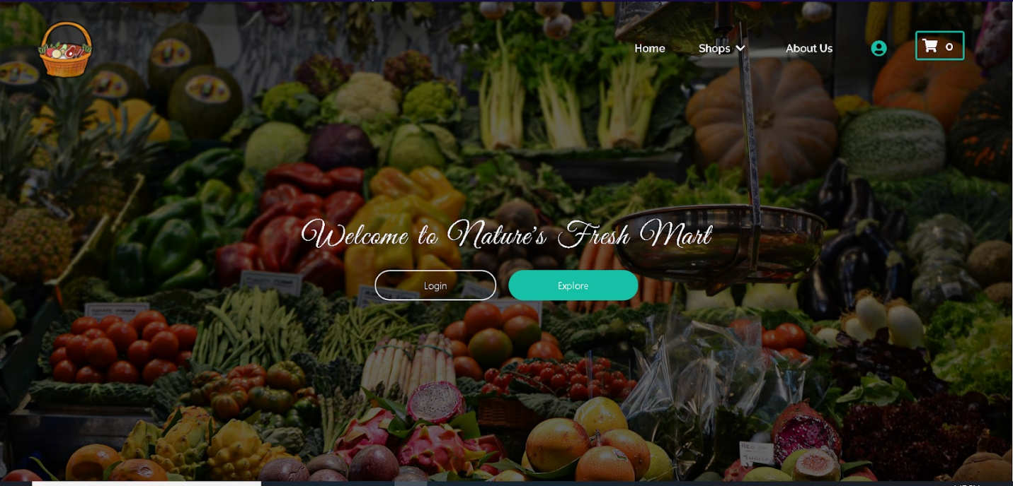

1. Inside the **Admin Panel** the first section the admin sees is the **Profile** section where he can update his personal details

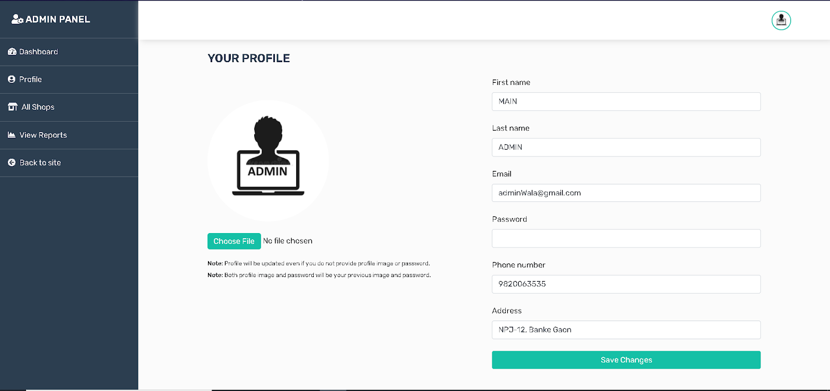

1. In the **Dasboard** the admin can view the details of all customers

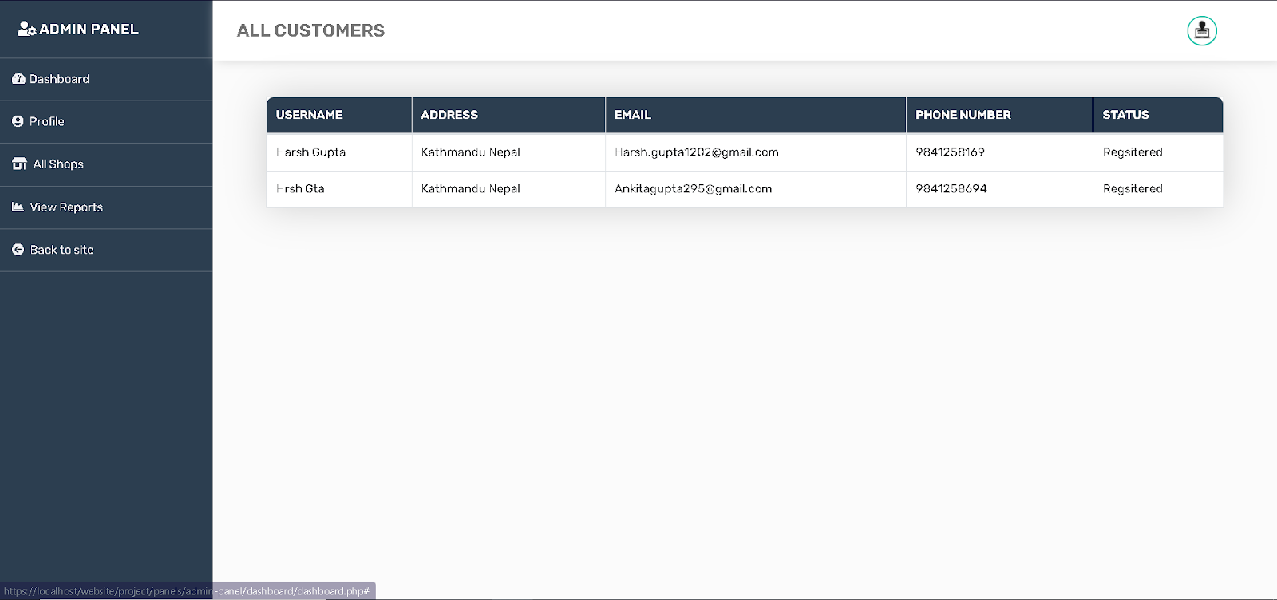

1. The next section is the **All Shops** section where the admin can view all traders and their respective shops along with their product categories. From this page the admin can also **Login as trader** which will take the admin to the **Trader Panel** of that specific trader, where he may enable or disable the trader’s products

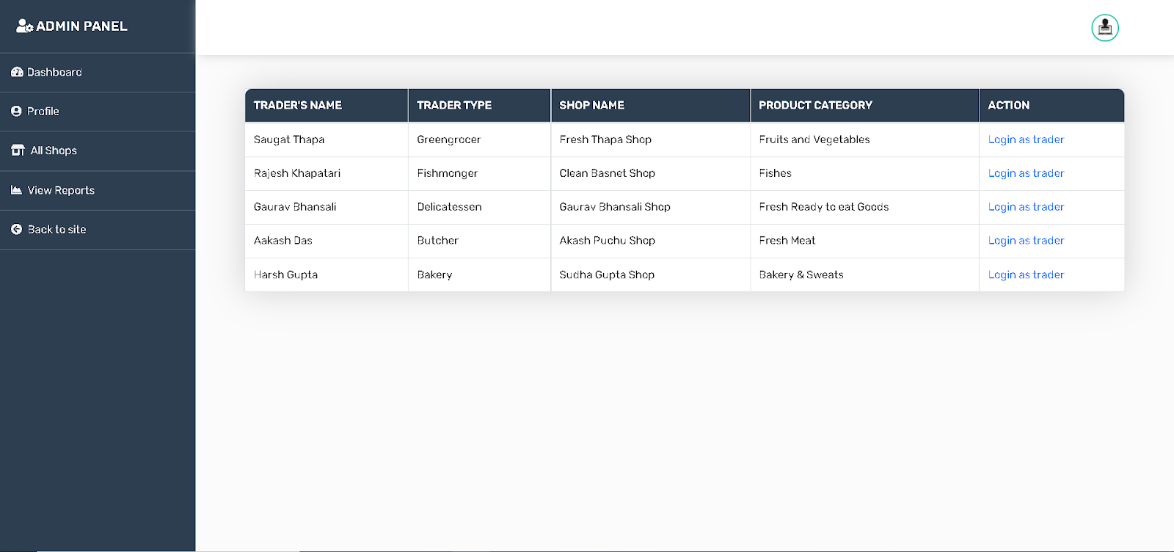

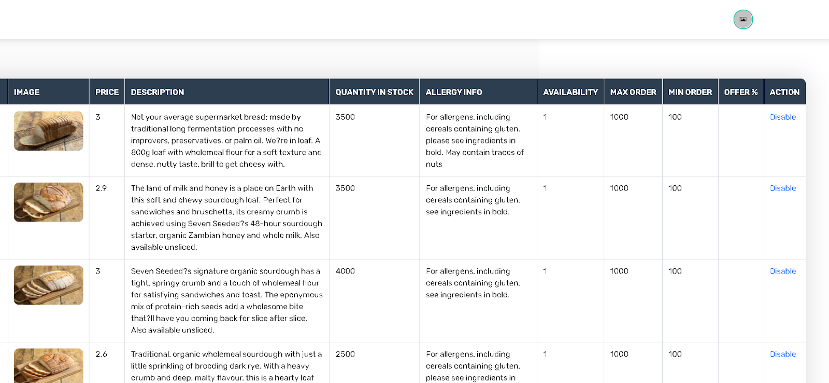

1. If you want to view reports of all the traders then you need to click on **View Report** button on the top right of your **Dashboard**. After clicking on it will redirect you to Oracle Dashboard from where you can login with your username and password.



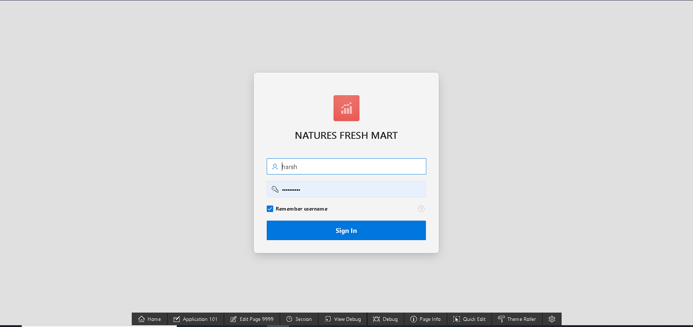

1. You can logout by clicking on username and then **Sign out**.

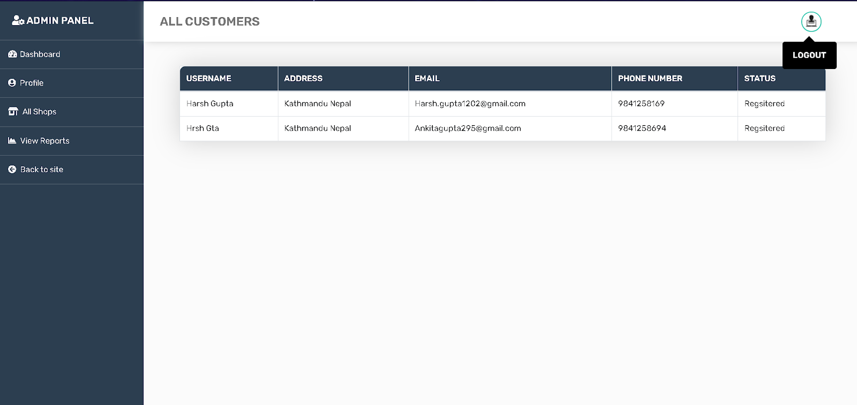

THANK YOU!!